JAMES P. GILVERO
KIT FRANCIS BESA
STEPHEN GABARDA

1. When you successfully used the payload to overwrite the secret key variable, which pillar of the C.I.A. triad did you primarily violate? Explain why.
Overwriting the secret key primarily violates the Integrity pillar of the CIA triad. Integrity ensures that data remains accurate, consistent, and protected from unauthorized modification. By altering the secret key in memory through a buffer overflow exploit, the attacker changed critical data without authorization. This compromises trust in the system because the stored value can no longer be considered reliable or correct.

2. What specific vulnerability category did you exploit when you entered a string longer than 8 characters?
The vulnerability exploited is a buffer overflow, specifically a stack-based buffer overflow. The program allocated only 8 characters for password_buffer, but it did not enforce input size limits. When a longer string was entered, it exceeded the allocated memory space and overwrote adjacent memory, including the secret_key. This type of vulnerability allows memory corruption and can lead to unauthorized control of program behavior.

3. Why is your solution (#4 The Fix) more effective than simply “asking users to be honest”?
The solution is more effective because it applies technical security controls, such as input validation and bounds checking, which automatically prevent exploitation. Security must assume that malicious actors will attempt to bypass rules. Asking users to be honest does not stop attackers. Secure coding practices enforce protection at the system level, making exploitation significantly more difficult or impossible.

4. Imagine this was running the control system for a local power grid.
• Who might want to exploit this vulnerability?
Possible threat actors include:
- Nation-state cyber groups
- Cybercriminal organizations
- Hacktivists
- Terrorist groups
- Malicious insiders
These actors may target critical infrastructure systems to cause disruption, financial damage, or political instability.

• What would be the real-world consequence if the secret key (controlling the power switch) was overwritten by a pro cyber-attacker?
If the secret key controlling a power grid were overwritten, an attacker could manipulate power distribution systems. This could result in large-scale blackouts, equipment damage, economic losses, public safety risks, and grid instability. Past cyberattacks on electrical infrastructure demonstrate that such threats are realistic and potentially devastating.

References
Perplexity AI. (2024). Search results on buffer overflow and power grid cyber threats. Retrieved from https://www.perplexity.ai/search/7d5ad8f1-837f-4ac5-884b-8b322e421300
Fortinet. (n.d.). What is a Buffer Overflow? Retrieved from https://www.fortinet.com/resources/cyberglossary/buffer-overflow
Greenberg, A. (2017). How an Entire Nation Became Russia’s Test Lab for Cyberwar. WIRED. Retrieved from https://www.wired.com/story/crash-override-malware/
IronNet. (n.d.). Cyber Attacks on the Power Grid. Retrieved from https://www.ironnet.com/blog/cyber-attacks-on-the-power-grid

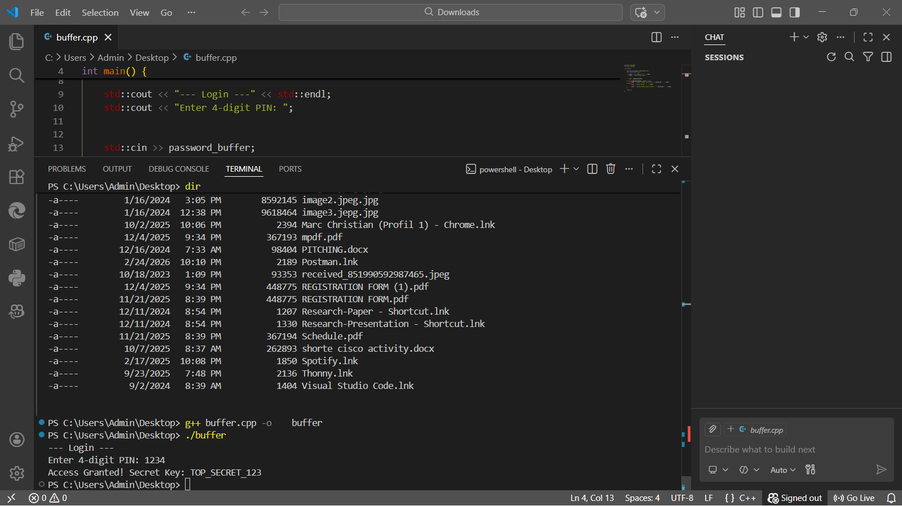
SCREENSHOT

